This is how it looks before the query parameter is added

//===========5. DIFFERENCE BETWEEN QUERY AND PATH PARAMETERS ===========

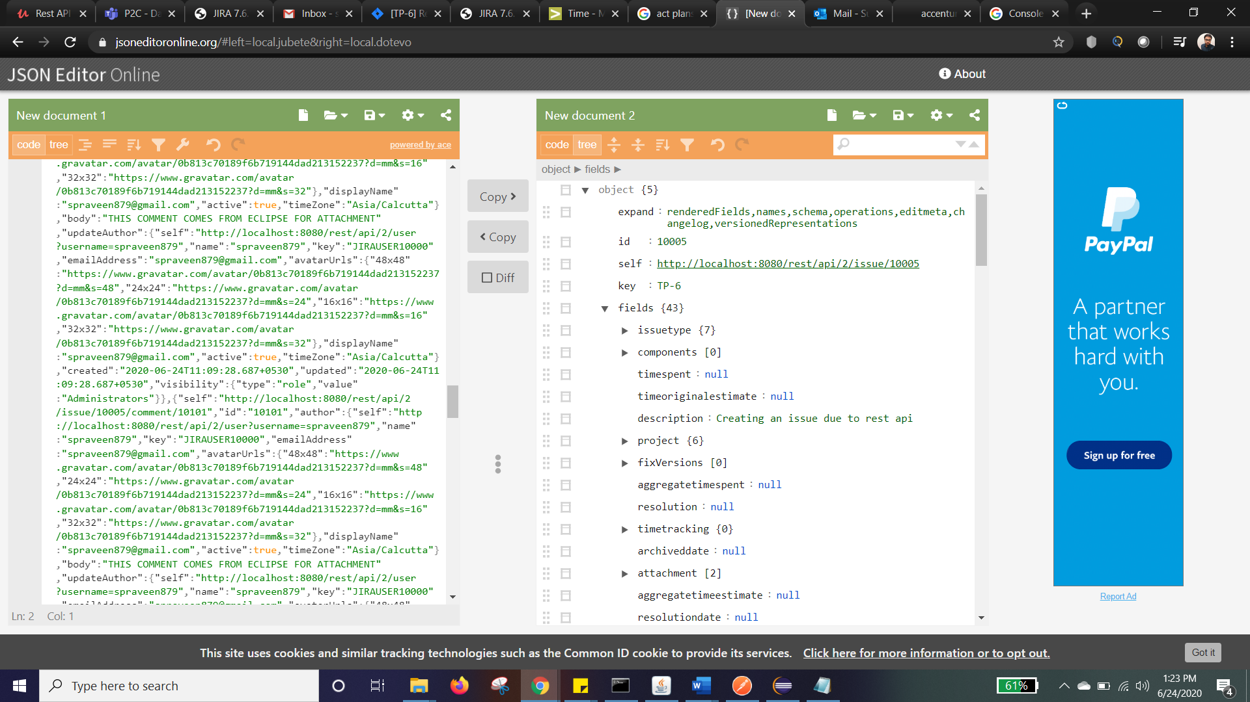

After query parameter is added, it looks like this

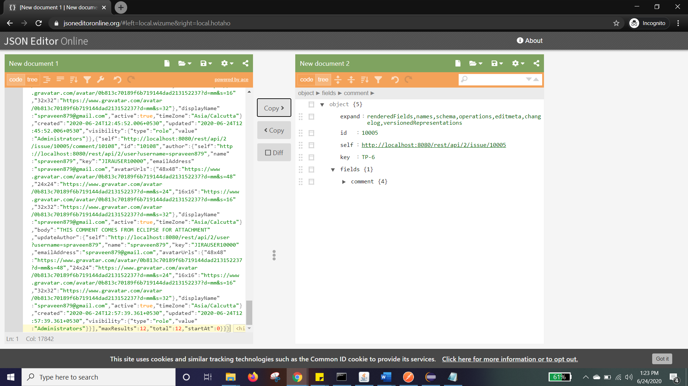

Out task is to fetch comment id from add comment and compare it with the json file using iteration and validate whether the comment is successfully added

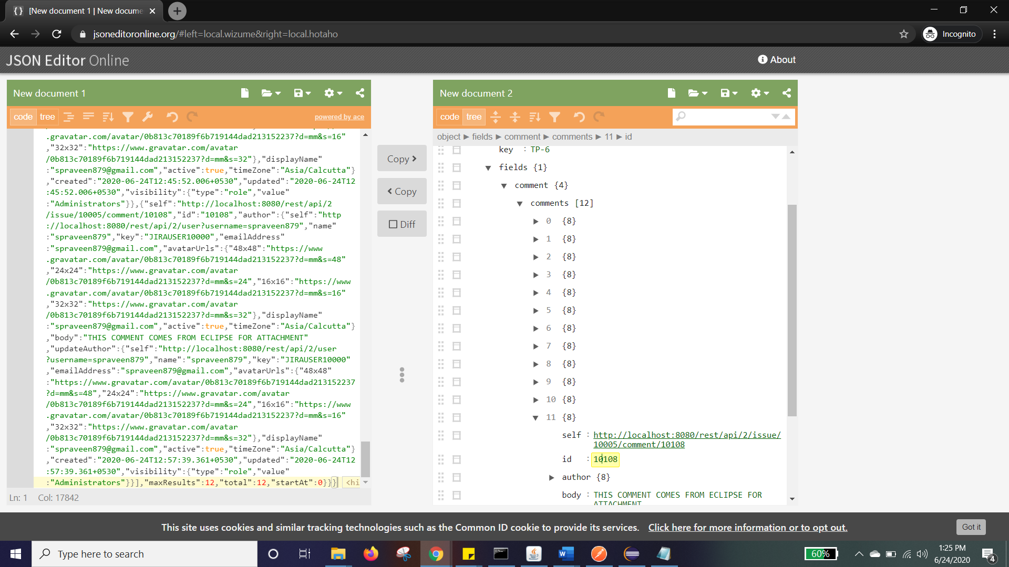

//==========6. VALIDATE WHETHER THE COMMENT IS ADDED =========

USE THE BELOW PATH TO TRAVERSE IN JSON

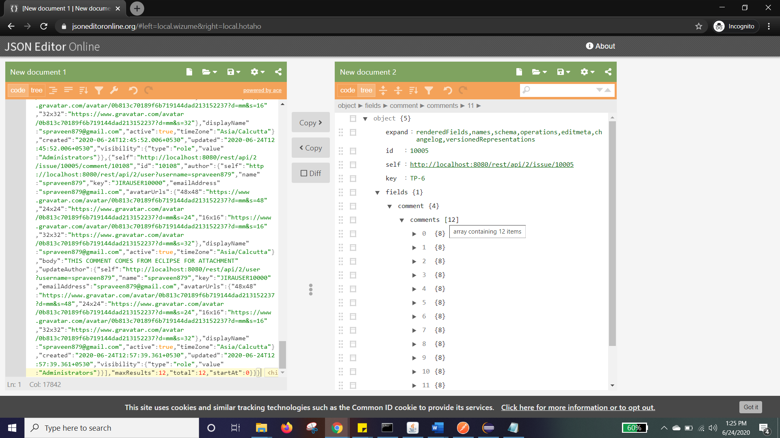

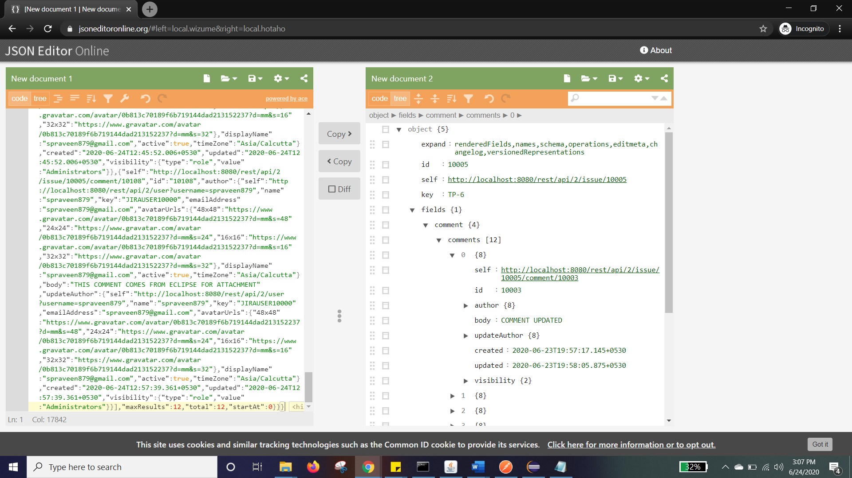

Here, we are checking whether the id is same. Post that we are asserting whether the body is same

JsonPath jp = **new** JsonPath(queryParamStr);

**int** count = js.getInt("field.comment.comments.size()")

**for**(**int** i=0;i<count;i++) {

String validateCmnt = jp.getString("fields.comment.comments["+i+"].id");

**if**(validateCmnt.equals(commentID)) {

System.***out***.println("Comment id is matched with id name "+commentID);

String cmntBody = jp.getString("fields.comment.comments["+i+"].body");

**if**(cmntBody.equals(cmntName)) {

System.***out***.println("The comment body is matched - "+cmntName);

}

}